

Department of Accountancy

Academic Advising Syllabus

Your Advisor

Name: Angela Gray
Pronouns: She / Her / Hers
Email: agrimald@niu.edu
Phone: 815-753-1637
Office location: BH 345A
Personal Availability Link (PAL)

What is Academic Advising?
- Advising is a developmental process.
- Advising fosters clarification of life and career goals.
- Advising assists in the development of educational plans.
- Advising is a decision-making process.
- Advising is an ongoing partnership.
- Advising is the shared responsibility of both you and your advisor.

Academic Advising Goals

Our College of Business provides professional academic advisors to assist you in meeting your undergraduate academic and career goals. Our advisors work collaboratively with you to:
- Explore and strive for academic and career goals and aspirations.
- Develop an academic plan guiding you to degree completion.
- Effectively use campus resources.
- Complete necessary paperwork and logistical items necessary to degree progress.

Expectations
Expectations of You | Expectations of Advisors
To be an active participant in your educational planning process. | Assist you to understand university policies and procedures, general education requirements, and program curriculums.
To strive for educational achievement to your highest attainable standard. | Encourage and guide you in the process of defining, developing and attaining your academic and career-related goals.
Initiate and maintain regular contact with your advisor (minimally once per semester). | Assist you in developing skills needed to create realistic and attainable educational plans.
Come prepared and on time for appointments. | Provide information regarding relevant campus resources and services that will assist you in enhancing your academic performance and college experience.
Be aware of and use our various campus resources as well as follow through with referrals. | Foster a collaborative partnership between faculty, staff and you.
Understand how to read and interpret your academic requirement report. | Maintain confidentiality.
Become knowledgeable about university policies, procedures and programs. | Uphold obligation as a Title IX responsible employee.
Identify your academic and career-related goals. | Be accessible to you for your questions and concerns.
Be responsible for developing your educational plan. | Encourage your ability to think critically, solve problems and make informed decisions about your future life plans.

Preparing for Your Meeting


Schedule Your Appointment

  - Make your appointment early in the semester.
  - Please schedule your advising appointment through Navigate or by calling 815-753-1637.
  - Arrive promptly for your meeting. If you are going to arrive late or cannot attend, please inform our office.


What to Bring

  - Current academic requirement report.
  - Ideas for desired class schedule.
  - Paper and pen (or pencil) for taking notes.
  - List of questions or concerns.
  - Any previous advising notes.


After Your Appointment

- Review the notes you took during your appointment as well as your advising worksheet.
- Follow through on any next steps/recommendations discussed during your appointment.
- Email me with follow up questions.
- Make another appointment if necessary.


Email Etiquette

Use your NIU email only.

Enter a clear subject line (e.g., “Question about MGMT 355”).

Include your full name and Z-ID number.

Do not be too casual with me. Write concisely in the body of your email. Proofread and spell check (no text abbreviations).
- Allow 72 hours for my response, excluding weekends and holidays. Trust me, I will get back to you!

Your Path to Graduation
Schedule Change Process for 16-week Courses

Sample Email

Dear Advisor,

My name is Victor E. Huskie, and I am emailing you today as I lost the advising sheet you gave me from our appointment last week. Can you please email it to me?

Thank you.
Victor E. Huskie:
Z1234567
Dates During Semester | Actions | Steps
Prior to first day | Add/Drop course | Self-service MyNIU.
Week 1 | Add/Drop course | Self-service MyNIU.
Week 2 | Add/Drop course | Contact course department.  Contact major college/ department.
Week 3 to end of  Week 10 | Withdraw course | Contact major college/ department.
Week 1 to end of  Week 10 (without academic jeopardy) | Withdraw all courses | Contact major college.

Advising Calendar
Month | To-do
June-August | - Meet with advisor during orientation session.  - Be aware of course add deadlines.
September | - Be aware of course drop and withdrawal deadlines.  - Call to schedule an advisement appointment for spring classes.
September-October | - Meet with academic advisor.
November | - Register online during registration appointment (available on MyNIU).
December | - View end-of-semester grades on MyNIU (contact me if you don’t pass a class with a C or better for us to discuss how this may impact next semester’s course schedule).
January | - Be aware of course add deadlines.
February | - Be aware of course drop and withdrawal deadlines.  - Call to schedule an advisement appointment for summer/fall classes.
February-March | - Meet with academic advisor.
April | - Register online during registration appointment (available on MyNIU).
May | - View end-of-semester grades on MyNIU (contact me if you don’t pass a class with a C or better for us to discuss how this may impact next semester’s course schedule).



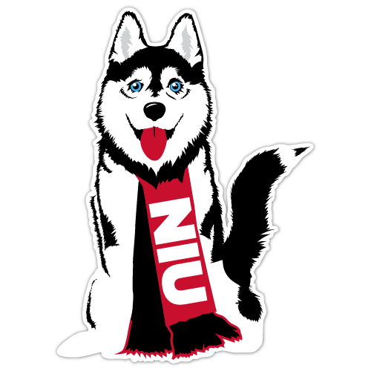
Additional Resources

Advising Resources
- Undergraduate Catalog — Your official source of information regarding academic programs and policies at NIU (go.niu.edu/catalog-ug).
- College of Business Advising Handbook (go.niu.edu/cobadvhandbook).
- Four-year degree paths (go.niu.edu/4yrdegreepath).

Student Organizations/Get Involved

Internships

Financial Assistance

Student Learning Outcomes
As a result of being an active participant in your academic advisement, you will be able to:
- Understand our general education requirements and College of Business Foundations of Business course requirements.
- Understand how your courses in your major(s) (and minor(s) or certificates, if applicable) fit together with general education requirements and relate to your overall learning goals and objectives.
- Correctly interpret the information on your DPR and apply the information to help determine appropriate course selection.
- Understand how to complete degree requirements and develop a plan for timely completion of your degree.
- Identify and develop your educational and career goals as they relate to your selection of major, minor, certificates and coursework to help you achieve your goals.
- Identify campus resources that help you reach your goals.
- Understand academic policies and procedures.

Graduation
- May graduation: Must apply between Aug. 1 and Feb. 1.
- August graduation: Same as May graduation (allows participation in May commencement ceremony).
- December graduation: Must apply between March 1 and Sept. 1.

Life After Graduation
- Contact NIU Career Services for assistance with résumé and job search techniques.
- Attend job fairs and recruiting events.
- Network. Network. Network.

